Leibniz-Institut für Wissensmedien / Schleichstraße 6 / 72076 Tübingen

Stiftung Medien in der Bildung (SbR) Leibniz-Institut für Wissensmedien
Direktorin: Prof. Dr. Ulrike Cress Schleichstraße 6
72076 Tübingen

Dr. Jens Maiero & Dan O’Brien Researchers
Tel +49 7071 979-314

j.maiero@iwm-tuebingen.de
www.iwm-tuebingen.de

Information for Study Participants

Dear prospective participant,

Thank you for your interest in our scientific study. Please read the following information carefully before deciding whether you and your child would like to participate. Participation in this study is entirely voluntary for both you and your child.

The information below explains the purpose of the study, what participation involves, how data will be collected and handled, and your rights as a participant and as a parent/legal guardian. If you have any questions about the study at any time, we will be happy to answer them and provide further clarification.

- Problem Statement and Aim/Purpose of the Research Project
In this study, we investigate children’s use of a virtual reality (VR) number line tool to learn about fractions. VR is a technology that overlays digital objects onto the physical space around the user. In this case, this is done using a Meta Quest 3 Head-Mounted Display (HMD) with hand controls. The goal is to enhance children’s conceptual understanding of fractions and some of the mathematical procedures with fractions that they will already be familiar with.

This study investigates how children interact with and evaluate a VR number line tool for lower secondary school mathematics. Your child’s input will help shape design features, instructional guidance, and lesson sequences for the tool. We will explore children’s usage of the tool and perspectives on how the tool could support their learning, with their feedback informing later phases of this Design-Based Research project.

- Study Procedure
You child is being invited to attend a focus group. During the session your child will observe a demonstration of a prototype VR learning tool, then explore the tool themselves using a supplied Head-Mounted Display. They will use the tool interactively to answer questions about fractions and then be asked to discuss their experience and suggest ideas for design improvements. The focus group will take no longer than 60 minutes.

Throughout the session, your child’s interactions with the VR tool will be logged by the computer system and recorded. Any written materials they produce may also be kept for analysis. Your child’s name will not be used in research outputs, and no individual will be identifiable in any report, presentation, or publication.

At the end of the session, your child will receive a short survey with Likert-scale questions on their views on the VR tool, including its design, usability, potential educational value, and possible classroom implementation.

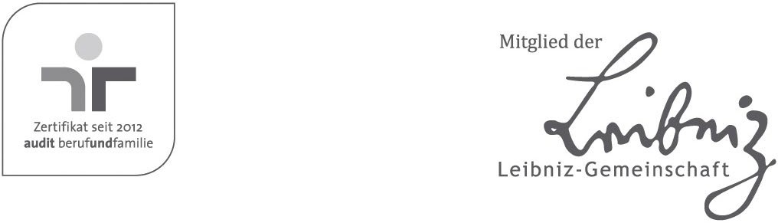
Vorstand:
Prof. Dr. Ulrike Cress Prof. Dr. Stephan Schwan Dr. Robert Polgar
IBAN DE73 6415 0020 000 2 722 977 BIC SOLADES1TUB
USt-IdNr. DE262703550

- Data Privacy
The study uses the Unity API to render VR images via a Meta Quest 3 Head Mounted Display. We do not transmit any personal data of children or parents to the computer system and no identifiable data is recorded.

- Voluntariness and Withdrawal
Participation in this study is entirely voluntary for both you and your child. Deciding not to participate, or choosing to stop participation at any time, will not result in any negative consequences.

You and your child may withdraw from the study at any point, without giving a reason. Your child may also take breaks or stop the study session whenever they wish. Children are informed about their right to stop participating in a manner that is appropriate for their age and understanding. They are reassured that stopping participation is acceptable and that neither the researchers nor their parents will be upset or disappointed if they choose to stop.

As a parent or legal guardian, you have the same right to withdraw your child from the study at any time. We kindly ask parents and guardians to respect and support their child’s decision if the child expresses a wish to stop participating.

- Benefits and Compensation
As a token of appreciation for your time, families will receive compensation of €12

Upon receipt of the compensation, you will sign a receipt stating your name and address. This information will be stored separately from the other data collected from you. These records are used solely for administrative and accounting purposes and are not linked to the scientific data collected in the study.

- Risks (Side Effects, Discomfort) for Participants
There are no risks or specific discomforts for your child.

This study has been approved by the local ethics committee of the Leibniz Institute for Knowledge Media (LEK 2026/043).

- Data Protection
All research data collected in this study, including written answers and activity log data, are anonymous. The research data themselves do not contain direct identifiers such as names or contact details.

Directly identifying information (e.g., names and contact details), which is required for administrative purposes (e.g., consent documentation or compensation handling), is stored separately from the research data in secure, access-restricted locations. Only authorized members of the research team have access to this information and are bound by professional confidentiality. Under no circumstances may confidential information be disclosed to third parties.

- Retention Period for Research Data
The anonymous research data (e.g., written answers and activity logs) are stored for a period of at least ten years to allow for scientific analysis, verification of results, and documentation in accordance with good scientific practice.

Research findings will be reported and published only in aggregated and anonymized form, such that individual participants cannot be identified in any publications or presentations.

- Data Protection Officer
Prof. Dr. Tobias Keber, State Commissioner for Data Protection and Freedom of Information Baden-Württemberg: poststelle@lfdi.bwl.de

Bert Bormann, IWM Data Protection Officer: datenschutz@iwm-tuebingen.de

10. Responsible contact person during the study
Dr. Jens Maiero
Researcher
Schleichstraße 6, 72076 Tübingen
Telefon: +49 7071 979-160
j.maiero@iwm-tuebingen.de

